U-M stem cell trial produces positive results for ALS patients
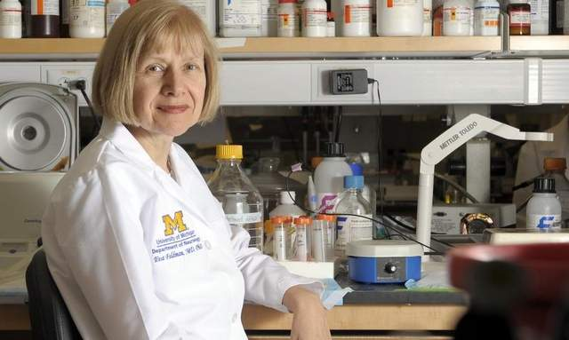

Dr. Eva Feldman, a University of Michigan professor and neurologist, says the results of the stem cell clinical trial are extremely hopeful. (David Guralnick/The Detroit News)
When Ted Harada agreed to participate in a clinical trial testing stem cells in patients with Lou Gehrig’s disease, doctors warned him he could become paralyzed, or even die.
Instead, Harada experienced something almost unheard of in patients with an incurable disease: His symptoms improved.
As part of the trial led by a University of Michigan researcher, Harada had two surgeries in which 1.5 million stem cells were injected into his lower and upper spine.
Soon after the first surgery, Harada stopped using a cane. He regained strength in his arms and hands and even participated in a three-mile walk to raise awareness about Lou Gehrig’s disease, or amyotrophic lateral sclerosis, an aggressive, progressive neuro-degenerative disorder that affects the nerves and brain.
“We’ve all heard the slogan, ‘You can’t win the lottery unless you buy a ticket,’ ” said Harada, 41, who lives near Atlanta, Ga., with his wife and three children. “I am not a lottery player, but in this case I was. Maybe I will get lucky.”
Harada is among four patients who have either improved or stabilized in the closely watched clinical trial, the nation’s first to use stem cells in patients with the disease — named after the New York Yankees legend whose career was cut short by the disorder. Gehrig died in 1941 at age 37. The disease typically kills patients in three to five years. Only one treatment is available, and it extends life by just a few months.
The four patients who stabilized or improved in Phase I of the trial had two clinical features in common: At the time of surgery, they were early in the course of their disease — an average of two years and one month after the onset of symptoms. They also had none of the ALS symptoms known as “bulbarfeatures” — trouble speaking or swallowing.
Though preliminary, the results offer hope, said Dr. Eva Feldman, a University of Michigan professor and neurologist who is the trial’s principal investigator.
“The results suggest that intraspinal stem cell transplantation of ALS subjects with no bulbar symptoms early in the course of their disease could slow disease progression,” Feldman said. “I am extremely hopeful that we have found a way early in the course of the disease to make a true difference. Any treatment that can slow the progression of the disease is truly a home run for Lou Gehrig.”
ALS affects as many as 30,000 Americans at any given time, according to the ALS Association, a national nonprofit providing assistance to those with the disease.
The clinical trial was launched in 2010 with 15 patients at Emory University in Atlanta, and is expected to expand to U-M soon with 15 more patients at both locations for the second phase.
Although a small group of patients improved or stabilized during Phase I of the trial, five of them have since died from the disease. A sixth patient died of a congenital heart defect unrelated to ALS.
The other five patients in Phase I are still alive but had a long disease course before entering the trial, and do not represent typical ALS.
During the first phase of the trial, surgeons injected up to 1.5 million stem cells into either the lumbar, cervical or both parts of the spinal column, first in patients who could not walk and then in those able to walk. The doctors areinjecting fetal stem cells provided by Neuralstem Inc., a Maryland company.
Phase II will involve more injections and millions more stem cells and will focus on the upper portion of the spinal column, where nerve cells supply the diaphragm. When those cells are damaged, patients have difficulty breathing, which is a common problem in ALS patients.
Feldman, who is also president of the American Neurological Association, said she believes the stem cells played a therapeutic role in the small number of patients who stabilized or improved.
“The stem cells surround the sick nerve cells and help nurse them so they can remain more stable,” Feldman said.
At the beginning of the trial, Feldman stressed Phase I was an important step to determine if the stem cell treatments are safe. She recently reported the improvement of patients at a conference in Romania and is preparing to submit the results to a peer-reviewed journal.
It’s not unusual to hear about early results of a high-profile trial, but people should not read too much into it, said Steve Goodman, associate dean of clinical and translational research at the Stanford University School of Medicine.
“In an incurable disease with little hope, any glimmer of information that a useful therapy might be in the works is, of course, newsworthy, as long as release of such information does not compromise the treatment of current or future patients,” said Goodman, who is not familiar with Feldman’s clinical trial.
“That said, if the release occurs before efficacy and safety are well enough established, there is always the possibility that desperate patients outside the trial will clamor for the therapy, which can be dangerous in itself, or make future studies difficult. And of course, if there is a financial interest in disseminating results, that raises questions about both the motivation and ethics of raising too much hope on the basis of very early-phase results.”
In spite of experts who warn about early results leading to premature hope, those with loved ones who have succumbed to ALS are thrilled to hear there could be some movement in the future for better treatments.
Among them is Malcolm Beaton, an Allen Park resident who lost a father, two brothers and four sisters to the disease.
“Everything quits working but your mind. You know everything that is going on around you, but you cannot communicate,” said Beaton, 77. “It’s a horrible, horrible disease.
“God bless those scientists that are doing that research. If they come up with a cure, imagine how that would have affected my family. I might maybe still have my brothers and sisters here.”

